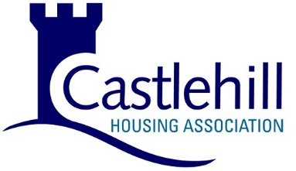

## **Castlehill Housing Association: Annual Assurance Statement to the Scottish Housing Regulator 2024**

The Management Committee of Castlehill Housing Association (CHA) is satisfied that CHA is compliant with the requirements of Chapter Three of the Regulatory Framework and the Regulatory Standards of Governance and Financial Management, with all relevant standards in the Scottish Social Housing Charter and all relevant legislative duties. We have gained this assurance from scrutiny of comprehensive evidence supplied to us by senior management and from our ongoing governance and oversight of CHA. Where appropriate, we have obtained external support to provide us with additional assurance that our approach is effective and robust.

The evidence provided combines reports, policies, audit activities, advice, and information that the Management Committee monitors and oversees throughout the year to provide continuous assurance that CHA is compliant. The evidence incorporates relevant documents and information that contribute to our assurance and that structure CHA’s business and governance activities.

We are confident that, taking account of the current economic and social environments, we continue to meet our responsibilities to our tenants, service users, regulators and funders. We have communicated our service delivery arrangements to our tenants clearly. We are confident that we have successfully maintained normal service levels, subject only to external supply constraints.

We are satisfied that we meet all of our duties in relation to tenant and resident safety. In particular, we have gained the necessary evidence-based assurance of our compliance in respect of duties relating to gas, electrical, fire, water and lift safety and our obligations relating to asbestos, damp and mould. We have obtained specialist advice to monitor our compliance on tenant safety issues and support our assurance.

In reviewing our compliance with the Regulatory Framework, we are assured that we have established appropriate systems for the collection of equalities data. We are assured that we are working towards using this data to take account of equality and human rights issues in our decisions, policy making and day-to-day service delivery.

We are assured that CHA has the necessary arrangements in place to identify any risks to compliance in the course of the conduct of our business and governance arrangements, and we recognise the requirement to notify the Scottish Housing Regulator (SHR) of any changes in our compliance during the course of the year.

We confirm that this Assurance Statement is being published on the CHA website on the same date that it is submitted to the SHR.

As Convener, I was authorised by the Management Committee at a meeting held on 28th October 2024 to sign and submit this Assurance Statement to the Scottish Housing Regulator.

Signed: Bob Hutcheson, Convener.

Date: 28th October 2024.